Communication from Pilot Study.

## For entity with wrong span but correct entity tag:

Annotator from MC annotated:

*recombinase*

correct span:"Cre recombinase"

[WS_GP](https://hypothes.is/search?q=tag%3AWS_GP)

Following our tagging scheme, in this example, annotators only need to use Hypothes.is to select the entity with correct span and use [WS_GP] to indicate the original tag is wrong span. As shown in the following screenshot.

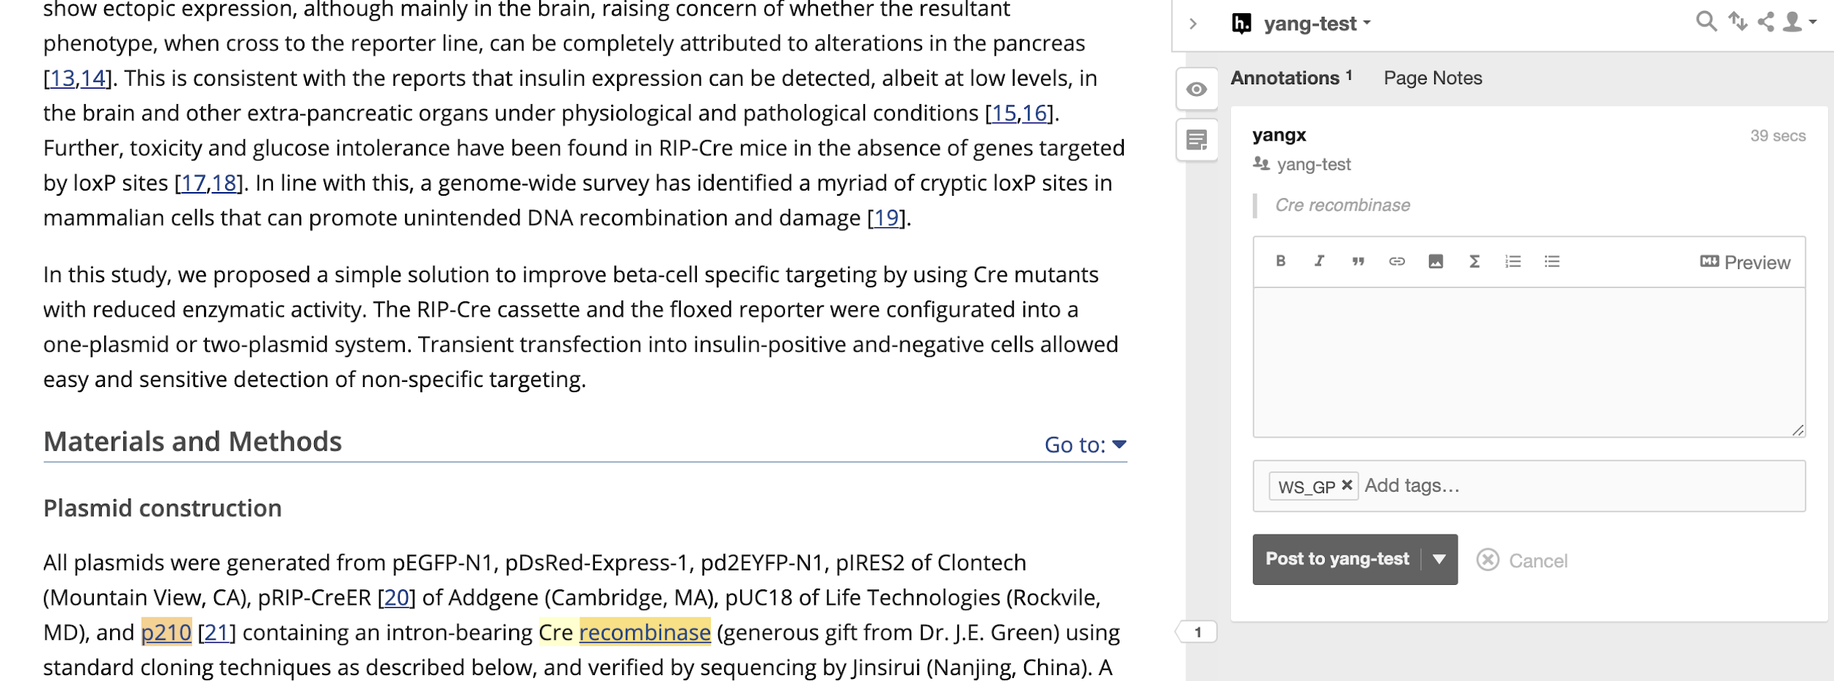

## 

## 

## 

## 

## 

## For entity with wrong type and wrong span:

Annotator from MC annotated:

*lymphoma*

this is an truncated phrase.. actual tagging should have been for "B-cell chronic lymphocytic leukaemia/lymphoma 11B"

[WT_DS]

*lymphoma*

lymphoma in this case is incomplete phrase, as this term is part of the protein name "B-cell chronic lymphocytic/lymphoma 11B".

WS_DS

*lymphoma*

The type taken for the term annotated is correct. However the span of the term taken is wrong. The correct span is "B-cell chronic lymphocytic leukaemia/lymphoma 11B" and the correct type is "GP". So added an additional tag for wrong span as well.

[[WT_DS][GP]](https://hypothes.is/search?q=tag%3A%5BWT_DS%5D%5BGP%5D)[WS]

As explained by one of the MC annotators, the correct span should be “B-cell chronic lymphocytic leukaemia/lymphoma 11B” and the correct type should be Gene/Protein.

In this example, annotator only need to select the entity with correct span and use [WT_DS][GP] to indicate that the original tag is wrong type and the correct type should be Gene/Protein. Annotator doesn’t need to mention the wrong span in this case since the entity type is more important. As shown in the screenshot below.

